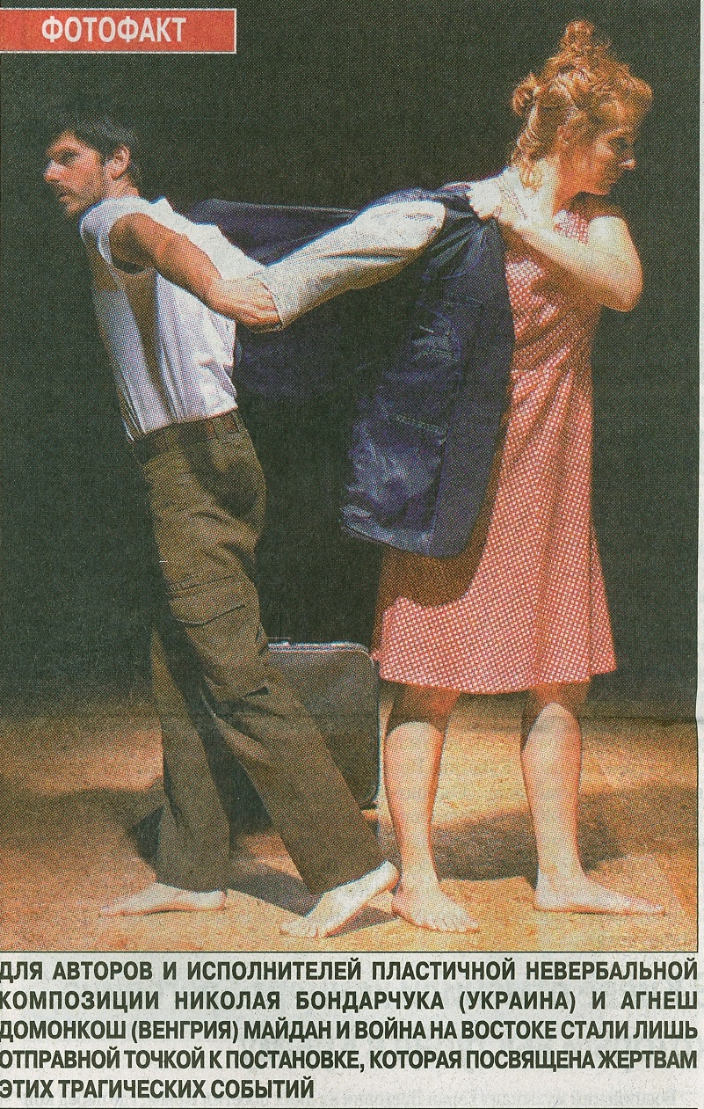
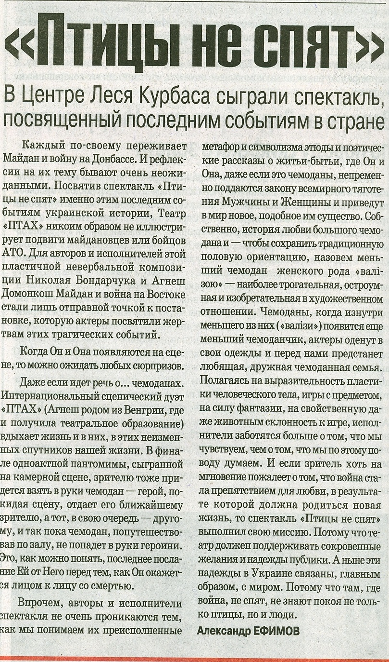
Translation
Birds Nevers Sleep- at Les Kurbas Centre, Kiev- a performance related to the recent happenings in Ukraine
Everybody has his own way of percieving the Maidan and East-Ukraine happenings, it’s still quite early time of reflection on these events.
Even if the performance „Birds Never Sleep” is related to this point of Ukrainian history, Ptah Theatre does not illustrate the Maidaner’s heroical actions or the antiterroristic fights in Ukraine.
For Mykola Bondarchuk(UA) and Agnes Domonkos(HU)- devisers and performers of this movement piece-Maidan and the East became just a starting point of creating the story related to the victims of these tragical fights.
-When they appear on stage whe can expect any kind of surprises-
Even if they use suitcases, the international company ”Ptah” blowes a life into these unchangable satelites of our existence. At the end of the mime piece audience has also a chance to take the case in their hands: the man gives it to the nearest spectator and hand by hand the case travels trough the whole audience until it reaches the woman. The last message from him to her before he meets the face of Death.
However, the performers aim is not to make us fully understood their creation. The main task is not how we specators understand the poetic episods rich in metaphores and symbols about life and existence.
He and She even if they’re represented by suitcases- will shurely be effected by the gravitation low of MAN and WOMAN and bring to the world a new and similar life. The lovestory of the two cases, where we can call - according to traditional orientation- the smaller case the „female one” is not only the most touching scene but artisticly very smart and creative as well. When the smallest suitcase appears from the female-case, it also gets dressed up by the actor’s clothes and the audience can see the image of a lovely family.
The actor’s focus is rather on what audience feels than what they think about the actions.
What gives a strong base to these actions: the clearness of body language, the use and manipulation of the objects, the power of phantasy and the animal-like playfullness trough the whole piece.
And if during the performance audience feels just for a moment the regret that war interrupted the love which could have brought a new life to the world- Birds Never Sleep fulfilled it’s mission. Because theater should support the inner wishes and hopes of the spectators.
Nowadays these hopes in Ukraine are mostly related to peace. Because where war is, there is no calmness, noone sleeps. Neither birds nor people.

Original article by Aleksandr Efimov at daily „ Den” UA, 02.04.2015

